**General Chemistry LabII-1112L**

# Lab Report#___10___

Andrew Kalathra, Department of Chemistry and Biochemistry, Lamar University, Beaumont TX 77710

**Title- Ksp Determination of Calcium Hydroxide1**

**Objective**- To explain the solubility of solid at equilibrium, and to determine the solubility of a compound.

**Procedure-**

* 1. First, we acquired our equipment and materials. This included setting up the LabQuest, setting up our pH probe, getting a little more than 30 mL of .05 M HCl and just putting 30 mL of it into our burette, and getting 20 mL of 1 M CaOH and filtering it.
  2. Next, we stirred/shook the filtered CaOH with the pH probe, and then recorded the calculated pH.
  3. We then started the titration. For the first titration set, we dropped .5 mL of the HCl into the CaOH, shook/stirred the solution with the pH probe, and recorded the pH of the solution (“shook not stirred”, Bond).
  4. We stopped the titration 4 drops after the pH dropped below 3.
  5. For our second titration set, we did not strictly drop .5 mL but dropped further away from our expected equivalence point, and smaller closer to our equivalence point.
  6. After completing our lab, we cleaned all our equipment into our waste beaker, neutralized it, and put it in the aqueous waste. All our equipment after that was cleaned normally, and our pH probe was stored upright.

**Data and Results**

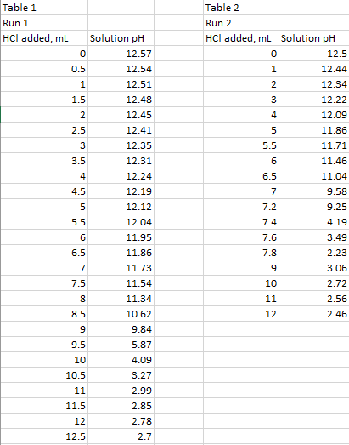

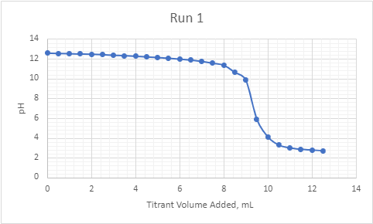

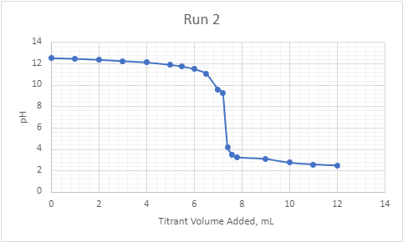

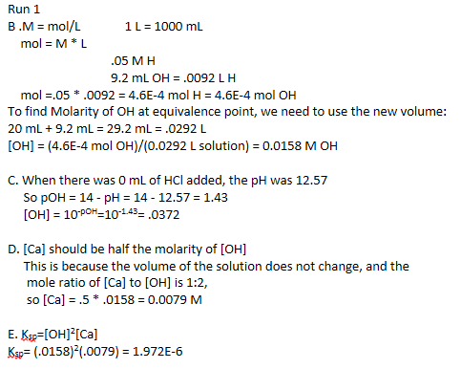

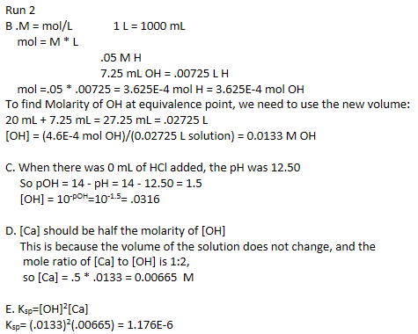

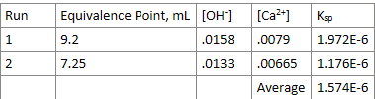

**Conclusions**

In conclusion, we found the solubility constant from titration. We did make mistakes along the way, some were our fault that we could have changed, and others were not. Our drops for the titration were not all to accurate, our pH probe was not stabilizing on a single pH value, even after mixing, and my estimated equivalence point might be off for both our runs. We did not get very close to the expected Ksp, but we understood the concepts.

**Key Questions-**

1. What is the KSP expression for the dissolution of Ca(OH)2 in water? -



2. What is the approximate equivalence point on the graph shown? - 8.1 mL

3. For calcium hydroxide an accepted value of Ksp = 5.02 x 10-6. Compare this to your team's average, what are some possible reasons for the discrepancy? - Per usual, we most likely messed up multiple things in the lab. As the pH probe was not very accurate (it kept switching between numbers, as said in the lab manual), we most likely did not always get the most correct reading of our solution. Along with that, we were most likely inaccurate with our .5 mL drops, resulting in inaccurate readings. Finally, I am not sure if my estimation of the equivalence points were correct, so there are many reason why we could have results vastly different than what was expected.

4. How might your team have experimentally determined the value of Ksp without titrating the sample? Show your calculation and compare it to the accepted value and to value obtained by titration. - First, we would have to experimentally find out the molarity of our OH or Ca. We then could perm the following operation:

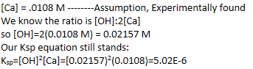

* Do not forget to attach the signed lab work-out

